1936 GOLIAD MEMORIAL AUDITORIUM RENTAL AGREEMENT PACKET NON-PROFIT ORGANIZATION
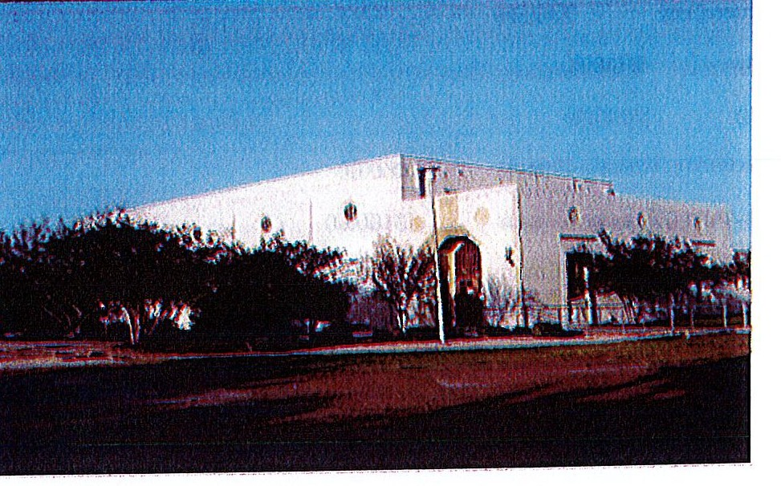

Lessee Name:
Event: Date of Event:

925 S. US Hwy. 183
Goliad, TX 77963

Auditorium Representative: Pamela Martin 361-645-3337
Notice to Lessee
The 1936 Goliad Memorial Auditorium is publicly owned and operated by the County of Goliad and the City of Goliad.

Rental fees associated with use of the auditorium are based on the cost of operation. The rate structure is periodically reviewed and, as necessary, it is adjusted to best match the costs.

Should an increase in the rate occur between reserving the auditorium and the date of the event, Lessee will be responsible for the increased charges. However, if this rental agreement is signed and returned to the auditorium representative before the rate increase, Lessee will only be responsible for the cost at the time the agreement was signed and submitted.

Fee Schedule

Non-compliance/Damage Deposit - Entire Facility Non-compliance/Damage Deposit - Selected Portions
$500.00

$50.00

Rental of Entire Facility (per day) Monday - Thursday Friday - Sunday

$300.00
$350.00

Basement/Kitchen Only $150.00 Foyer Area Only $100.00
Restrooms Only $100.00

Day-before Decorating Access - 4 hours Day-before Decorating Access - 8 hours
$50.00

$100.00

Proof of 501(c) charitable organization non-profit status must accompany completed rental agreement.

Rules for Use
Failure to comply with these rules will result in forfeiture of the non-compliance/damage deposit.

1.

Lessee must be 18 years of age or older.

2.

Th e auditorium is a smoke -free facility.

3.

Occupancy limits, as established by state law, must be observed. The maximum occupancy for the entire facility, including the basement and stage area, is 1,588 persons. If the basement and stage will not be utilized, maximum occupancy is 1, 334 persons.

4.

All marked, lighted EXIT doors must be unlocked. They must remain unlocked for the duration of the event.

5.

Children must be supervised by an adult at all times. Running is not allowed in any portion of the auditorium.

6.

No glass of any kind is allowed in the auditorium. This includes candleholders, drinking glasses, bottles, and all other types of glass.

A polite note in the invitation to the event, informing your guests that glass containers are prohibited will generally prevent problems. It is, however, the responsibility of Lessee to make certain that everyone complies with this restriction. We suggest that you assign someone the responsibility for checking all ice chests, tote bags, and such for glass containers; if they are found, guests can be asked to return the containers to their vehicles.

- Electric beer kegs, soda dispenser, slush machines, ice chests, and similar itemsmust be in good working order, such that no water or other liquids leak onto the floors. Iced beer kegs are allowed only in the basement. The event supeNisor is authorized to require the removal of any such containers or equipment at once, should they be found to be leaking.

- Ice may not be brought into the auditorium in bags. It must only be brought into the facility in ice chests.

- Bubble machines, smoke machines,fireworks of any type, sparkler machines, fog machines, dry ice, beach balls, tossing balls, floating devices, and other similarentertainment device s are strictly forbidden. Lessee is responsible for notifying entertainers or similar services of the restriction and for making certain everyone is in compliance.

- Dance wax is not allowed on the floors.

- All decorations must be free-standing, not attached in any way to the doors, walls, ceiling, floors, windows, woodwork, or tables. All floor decorations must have a padded base.

- No staples, thumbtacks, nails, tape, or glue may be used anywhere in the auditorium.

- Tabl es may only be decorated with fabric, plastic, or paper tablecloths that drape over the tables without being taped or tacked to the tables in any way. Table skirts must be pinned to tablecloths, without attachment to the tables.

- No confetti, glitter, bird see, flower petals, rice, or other similar "toss" items may be used.

- Tables and chairs are to be lifted for carrying. Do not drag them.

- Tables and chairs are not to be removedfrom the auditorium hall or foyer area for any reason. All tables and chairs not needed for an event must be stack ed on the chair trucks and table trucks, which must remain in the northeast corner of the auditorium. The trucks are not to be moved to the basement.

- Serving tables set up in the basement may not block any doors.

- Any tables or chairs moved from the basement to the audit orium hall or foyer must be returned to the basement.

- Lessee will immediately report any electrical, plumbing, or mechanicalproblems to lhe event supervisor or auditorium representative.

- The non-compliance/damagedeposit will be fully refundedto the Lessee, provided that Lessee is in full compliance with all of the rules listed here and that no damage has occurred. Checks will be mailed within fourteen (14) business days following the event.

- Failure to comply with all rules outlined in the rental agreement will result in the forfeiture of the deposit.

- If damage of any kind occurs to the auditorium during the rental period, the cost of repairs will be deducted from the deposit refund.Lesseewill be responsible for paying the damage costs that exceed the amount of the deposit.

- Rental is strictly on a first-paid, first-served basis. However, a "date hold" deposit of
$100.00 will guarantee the availability of the date until full payment is made. This deposit becomes part of the non-compliance/damagedeposit. If the event is canceled, the date hold deposit is forfeited.

- An event supervisor, hired by Goliad County, will be on-site during the hours of the event. The event supervisor is not responsible for assisting with clean-up during or following the event. S/he will monitor compliance with all rules outlined in the rental agreement. S/he will also

inspect the facility immediately after the event for compliance with clean-up and storage rules and for damage to the auditorium.

Lessee's Responsibilities Before and After an Event
  - It is Lessee's responsibility to pick up the key from the auditorium representative prior to the event. The representative is available at the Office of the County Judge from 8 a.m. to noon and from 1 p.m. to 5 p.m., Monday through Friday.

  - All deposit and rental fees must be paid no later than two (2) weeks prior to the event;
this means that they must be paid no later than the tenth (10th) business day before the event.

  - The Lessee will place the provided plastic trash cans, with liners, outside the auditorium, near the front doors, to encourage attendees to dispose of all trash as they are leaving the event. Trash bags should be tied and placed in the dumpster. Lessee is also responsible for cleaning the grounds immediately outside the auditorium of any trash resulting from the event.

  - All food and supplies shall be removed from the premises, and the kitchen counters, sinks, and refrigerator will be wiped clean, if used.

  - All food and beverage containers (plates, bowls, cups, and such) must be placed in trash bags, which are to be tied and placed in the dumpste.r

  - All wooden tables, metal chairs, and poly-resin chairs must be returned to the basement.

  - All table coverings must be removed, and tables and chairs must be wiped down and stacked on the table trucks and chair trucks. Candle wax must be gently removed from tables without damaging the surfaces. Failure to stack and store tables and chairs will result in
$100.00 being deducted from the non-compliance/damage deposit.

  - All items brought to the auditorium by Lessee must be removed immediately following the event. If Lessee needs extra time, arrangements may be made before the event for removal on the following day; Lessee must contact the auditorium representative prior to the event, however, and all items must be remo ved no later than 10 a.m. on the following day.

Please note: Items not removed will be disposed of.

If two events are scheduled for consecutive days, this extended time will not be allowed. Lessee for the first event will be required to remove everything immediately following the event, and Lessee for the second event will not be allowed to enter the auditorium before 7 a.m. on the day of the event.

  - All doors must be locked and the keys must returned to the auditoriumrepresentative on the first business day following the event. Failure to return the keys will result in the cost of rekeying the locks being deducted from the non-compliance/damage deposit.

Event Information Form

Individual/Organization Leasing Auditorium: _
Date(s) and Hours (beginning and ending) of Event: _ Contact Person:
Mailing Address: _
Telephone Number: _

Descriptionof Event:

Number of Guests Expected: _

Space Required for Event:

O Entire facility
O Stage only
    - Foyer only
    - Basement/Kitchen only
O Restrooms only

Furniture Required for Event:
    - 8-foot banquet tables (27 available):

needed

O 5-foot round banquet tables (15 available): needed
    - 8-foot wooden tables (12 available): needed
    - Poly-resin stacking chairs (300 available): needed
O Metal folding chairs (100 available): needed

Use on day prior to event for decorating, etc.
O I do not need to access the auditorium on the day before the event. I understandthat I may not enter the premises prior to 7 a.m. on the date of the event, and I may not store any decorations, equipment, or personal items prior to that time.
o I need to enter the facility on the day before my event for a block of four (4) hours.I
understand that I will be charged an additional $50.00. I would like to access the building from
a.m./p.m. to a.m./p.m.
O I need to enter the facility on the day before my event for a block of eight (8) hours. I understand that I will be charged an additional $100.00. I would like to access the building from
a.m./p.m. to a.m./p.m.

Release and Indemnification Agreement
In consideration of the use of the 1936 Goliad Memorial Auditorium, located on U.S. Hwy 183, Goliad, Texas and jointly owned by the County of Goliad and the City of Goliad, Lessee agrees to defend, indemnify, and hold harmless the County of Goliad and the City of Goliad, their officers, agents, and employees from and against all liabilities, claims, and suits or demands for injuries to any person and/or damage to any property arising from the Lessee's use of the 1936 Goliad Memorial Auditorium. Lesseefurther agrees to pay for any damages to the facility arising out of the use of the 1936 Goliad Memorial Auditorium.

Signature of Lessee Date

Fee Summary ancl Record of Payments

Pl ease note: All f.ees and d eposits must be paid in full ten (10) business days prior to the event date.

Proof of 501(c) charitable or ga nization non-profit status must accompany completed rental agreement.

Lessee Name: _ Event Date(s): _

Non-compliance/Damage Deposit Rental Fee
Extended Access Fee Total Fees
Payments Made
$500.00

